HANDS Workshop

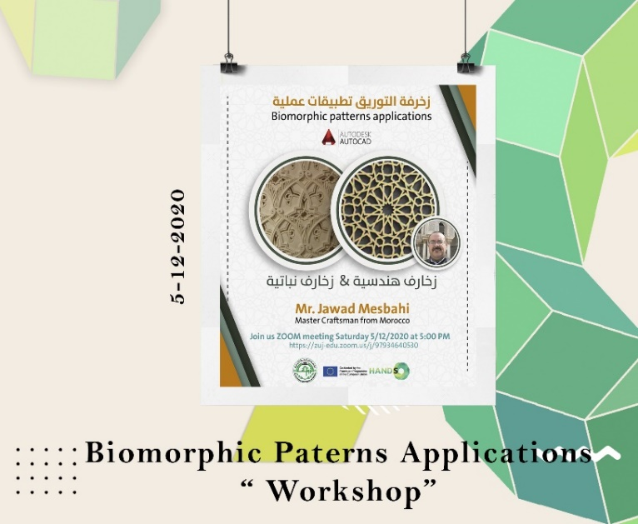
Vocational Workshop - Biomorphic Patterns Applications

WP 6: DEVELOPMENT
Date: Saturday, 5/12/2020
Organizer: Al-Zaytoonah University of Jordan
Location: Online via Zoom
Jawad Mesbahi, a Moroccan craftsman, led an online HANDS workshop on "Biomorphic Patterns Applications." Students engaged in practical exercises, designing biomorphic/geometric patterns to foster creativity and skill development. The workshop addressed geometric pattern design techniques, offered hands-on activities, and encouraged innovation in traditional designs, enriching artistic expression.

